INTEGRATIVE COURSE IN PSYCHOLOGY (ICOPSYCH)

ANALYSIS ON THE RESULT OF PRE-TEST EXAMINATION IN ABNORMAL PSYCHOLOGY
April 12, 2025

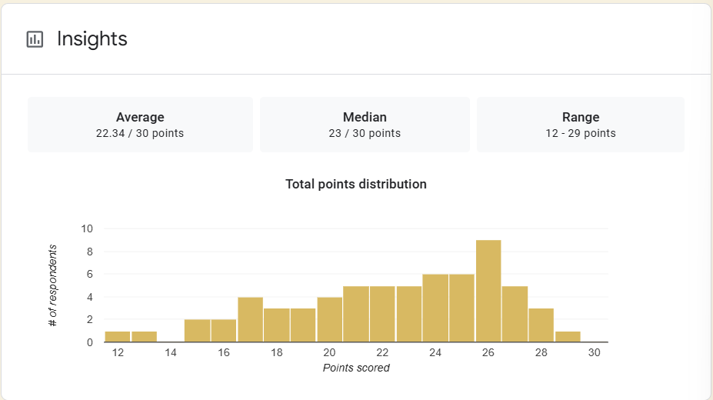

1. Mean Score: The average score is 22.34, which suggests that, overall, participants performed fairly well, scoring about 74.5% on average.

2. Median Score: The median score is 23, which is slightly higher than the mean. This implies that half the participants scored 23 or above, showing that a significant portion performed above average.

3. Range: The score range is 17 points, from 12 to 29. This indicates a wide spread in performance, some participants struggled (12/30 = 40%), while others nearly achieved a perfect score (29/30 = 97%).

Interpretation Summary:

-The group performed relatively well overall, with the average and median both above 70%. This indicates a solid general understanding or performance on the test.

-The distribution appears slightly left-skewed, suggesting a few lower scores are affecting the mean. The higher median than mean could suggest a slight left skew in the distribution; a few lower scores may have pulled the mean down.

-There's a significant variability in performance, indicating differences in participant ability or knowledge level. The wide range points to possible variability in skill level, preparedness, or understanding among participants.

RATIONALIZATION:

DIFFICULT QUESTIONS:

